**Tanzania country profile**

Published

15 November 2018

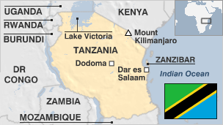

**Tanzania has been spared the internal strife that has blighted many African states.**

Domestic stability has not translated into economic prosperity for Tanzanians, however. Many of its people live below the World Bank poverty line, although the country has had some success in wooing donors and investors.

Tanzania is home to two renowned tourism destinations - Africa's highest mountain, Kilimanjaro, and wildlife-rich national parks such as the Serengeti - but has become a target for poachers.

Conservationists have warned that the entire elephant population could die out by the end of the decade if they continue to be killed for their ivory at the current rate.

* Read more profiles by [BBC Monitoring](http://bbc.co.uk/monitoring)

**President: John Magufuli**

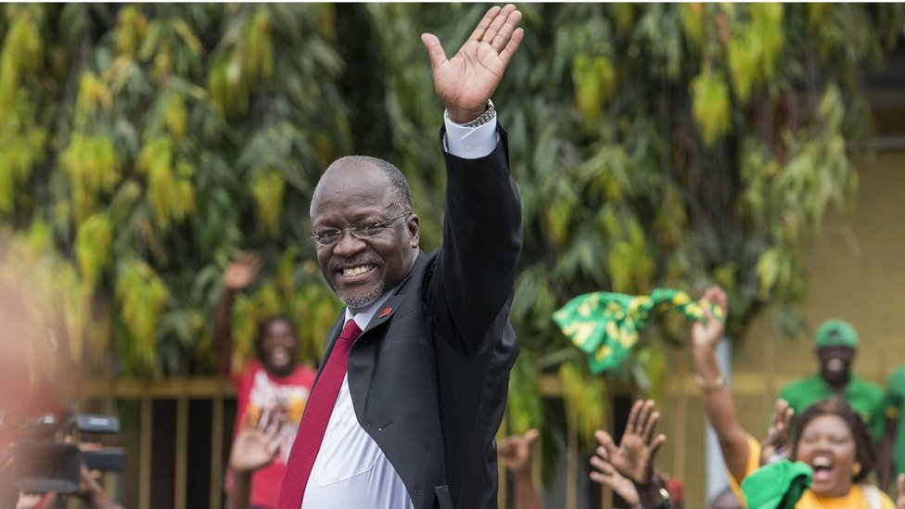image copyrightGetty Images

Nicknamed "The Bulldozer" for his energetic road-building drive and reputation for honesty as a minister, John Magufuli stood for president in 2015 on promises to boost economic performance and, like the opposition, fight corruption.

His other major election pledges - to tackle youth unemployment and establish free primary and secondary education - will to a large degree depend on cautious management of resources.

Mr Magufuli has caused international concern over his campaign against the independent media and gay rights.**MEDIA**

Laws encourage self-censorship while threats and attacks against journalists hinder critical reporting, according to US-based Freedom House.

That has not stopped the country's media scene from developing: once small and largely state-controlled, the media industry has grown rapidly following the advent of the multi-party era in the mid-1990s.

Television was a latecomer, with state TV launched only in 2001.

# Tanzania profile - Timeline

Published

15 November 2018

**A chronology of key events:**

**1498** - Portuguese explorer Vasco da Gama visits Tanzanian coast.

**1506** - Portuguese succeed in controlling most of the East African coast.

**1699** - Portuguese ousted from Zanzibar by Omani Arabs.

**1884** - German Colonisation Society begins to acquire territory on the mainland.

**1886** - Britain and Germany sign an agreement allowing Germany to set up a sphere of influence over mainland Tanzania, except for a narrow piece of territory along the coast which stays under the authority of the sultan of Zanzibar, while Britain enjoys a protectorate over Zanzibar.

**1905-06** - Indigenous Maji Maji revolt suppressed by German troops.

## British rule

**1916** - British, Belgian and South African troops occupy most of German East Africa.

**1919** - League of Nations gives Britain a mandate over Tanganyika - today's mainland Tanzania.

**1929** - Tanganyika African Association founded.

**1946** - United Nations converts British mandate over Tanganyika into a trusteeship.

**1954** - Julius Nyerere and Oscar Kambona transform the Tanganyika African Association into the Tanganyika African National Union.

## Independence

**1961** - Tanganyika becomes independent with Julius Nyerere as prime minister.

**1962** - Tanganyika becomes a republic with Mr Nyerere as president.

**1963** - Zanzibar becomes independent.

**1964** - Sultanate of Zanzibar overthrown by Afro-Shirazi Party in a violent, left-wing revolution; Tanganyika and Zanzibar merge to become Tanzania with Mr Nyerere as president and Afro-Shirazi leader Abeid Amani Karume as vice-president.

**Socialism**

**1967** - Mr Nyerere issues the Arusha Declaration, which launches drive for socialist economic self-reliance.

**1977** - The Tanganyika African National Union and Zanzibar's Afro-Shirazi Party merge to become the Party of the Revolution, which is proclaimed to be the only legal party.

**1978** - Ugandans temporarily occupy a piece of Tanzanian territory.

**1979** - Tanzanian forces invade Uganda, occupying the capital, Kampala, and help to oust President Idi Amin.

## Multi-party politics

**1985** - Mr Nyerere retires and is replaced by the president of Zanzibar, Ali Mwinyi.

**1992** - Constitution amended to allow multi-party politics.

**1995** - Benjamin Mkapa chosen as president in Tanzania's first multi-party election.

**1998** August - Al-Qaeda Islamist terror group bombs US embassies in Tanzania and Kenya.

**2000** - Mr Mkapa elected for a second term, winning 72% of the vote.

## Zanzibar violence

**2001** January - At least 31 people are killed and another 100 arrested in Zanzibar in protests against the government's banning of opposition rallies calling for fresh elections; government sends in troops.

**2001** March - Governing Chama Cha Mapinduzi and main Zanzibari opposition Civic United Front agree to form joint committee to restore calm and to encourage return of refugees from Kenya.

**2001** April - Tens of thousands of opposition supporters march through the commercial capital, Dar es Salaam, in the first major joint demonstration by opposition parties in decades.

**2001** July - Huge new gold mine, Bulyanhulu, opens near northern town of Mwanza, making Tanzania Africa's third largest producer of gold.

**2001** November - Presidents of Tanzania, Uganda and Kenya launch regional parliament and court of justice in Arusha to legislate on matters of common interest such as trade and immigration.

**2001** December - Britain approves controversial deal to sell military air traffic control system to Tanzania. Critics say it is a waste of money.

**2005** March-April - Political violence in semi-autonomous Zanzibar ahead of voter registration for October poll.

**2005** October - Governing Chama Cha Mapinduzi wins Zanzibar elections. Opposition Civic United Front claims vote-rigging and announces an indefinite boycott of Zanzibar's parliament.

## Kikwete elected

**2005** December - Jakaya Kikwete, foreign minister and ruling Chama Cha Mapinduzi candidate, wins presidential elections.

**2006** August - The African Development Bank announces the cancellation of more than $640m of debt owed by Tanzania, saying it was impressed with Tanzania's economic record and the level of accountability of public finance.

**2008** January - Central Bank Governor Daudi Ballali is sacked after an international audit finds the bank made improper payments of more than $120m (£60m) to local companies.

**2008** February - President Kikwete dissolves cabinet following corruption scandal which forced the prime minister and two ministers to resign.

**2009** November - Main opposition party in Zanzibar, Civic United Forum, ends five-year boycott of the island's parliament ahead of upcoming elections.

## East African Common Market

**2010** July - Tanzania joins its neighbours in forming a new East African Common Market, intended to integrate the region's economy.

**2010** September - President Kikwete says construction of highway through Serengeti game reserve will go ahead, despite criticism from environmental experts.

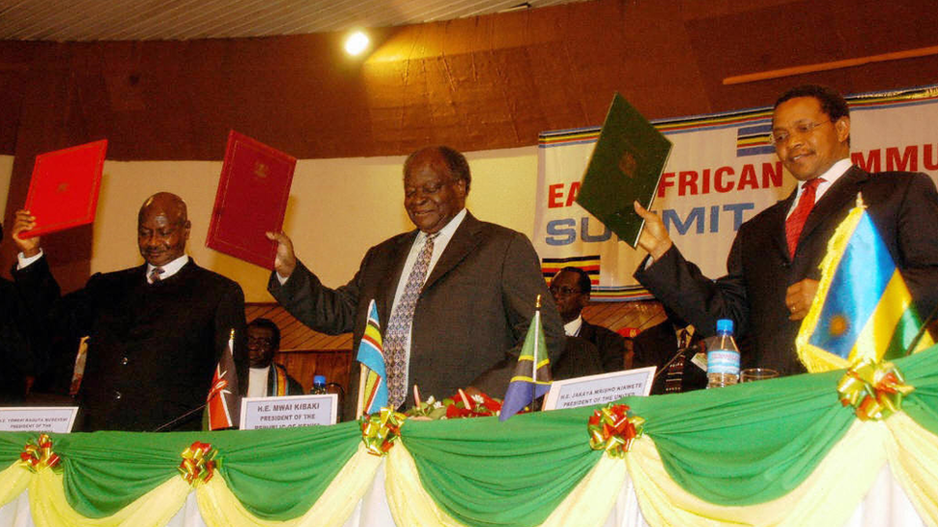image copyrightStringer/afp/getty images

image captionThe East African development strategy plan for 2006-2010 was launched in Tanzania

**2011** January - Two killed as police try disperse demonstrators demanding release of Chadema opposition party leader Freeman Mbowe, detained ahead of a rally against government corruption.

**2011** July - British arms and aircraft firm BAE Systems admits setting up sham compensation arrangements worth £8m for the sale of an overly-complex air-traffic control system, and agrees to pay Tanzania £30m in compensation.

**Gas find**

**2012** March - The Statoil and Exxon Mobil oil exploration companies make major discovery of gas reserves off the coast of Tanzania.

**2012** May - President Jakaya Kikwete sacks six ministers after the inspector of public finances notes the "rampant misuse of funds" in at least seven ministries. The ministers of finance, energy, tourism, trade, transport and health lose their jobs.

**2012** August - Tanzania confirms 36 Iranian oil tankers have been using Tanzanian flags to evade US and EU economic sanctions on Iran's crude oil exports. The US warns Tanzania that it could face sanctions unless the flag operation stops.

**2013** December - Four cabinet ministers are sacked over allegations of human rights abuses during a campaign against ivory poaching.

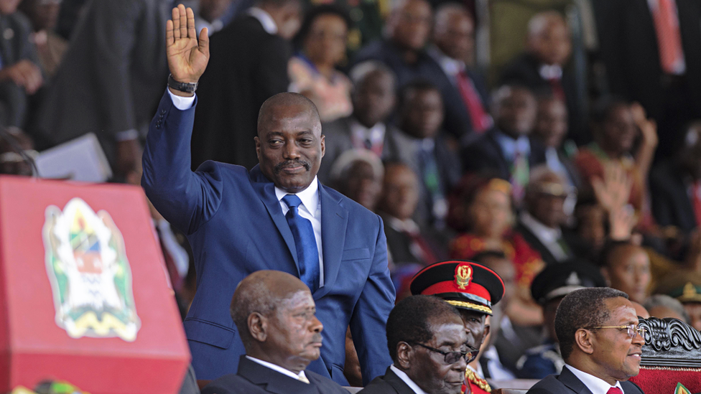image copyrightDaniel Hayduk/AFP/Getty Images

image captionPresident Magufuli's crackdown on the media and gay rights has caused international controversy

**2015** April - Referendum on a new constitution is postponed after delays in registering voters.

**2015** November - Works Minister John Magufuli of the governing Chama Cha Mapinduzi wins presidential election by large margin over former prime minister Edward Lomassa.

**2016** April - Tanzania and Uganda agree to build East Africa's first major oil pipeline.

## Anti-gay campaign

**2017** February - Government bans several private health centres from providing HIV and AIDS-related services, accusing them of promoting homosexuality.

The Mwanahalisi newspaper becomes the second paper to be banned in recent months. Rights groups says press freedom is under increasing threat.

**2017** October - Police detain a group of foreign lawyers discussing whether to challenge a government decision to limit the provision of health services which allegedly promote homosexuality.

**2018** November - Authorities deploy army to buy cashew nuts from farmers to solve a row over prices.Major donor Denmark suspends aid over anti-gay campaign.